**Steps to avoid Missing Authentication for Critical Function**

1. Telnet to device to port 9999

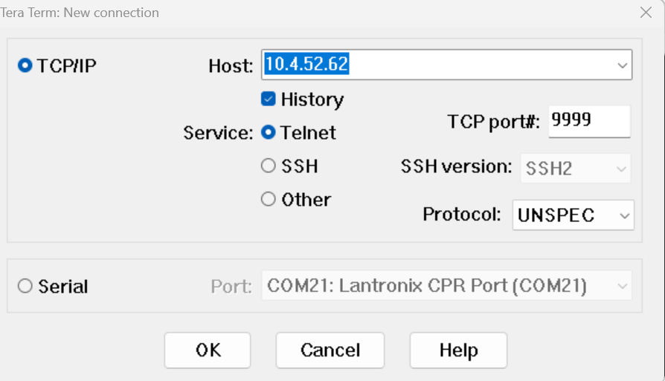

1. Disable accept incoming connection in connect mode and set port to 0

* Go to channel 1(option 1) change port number to 0 and connect mode C0 to 00

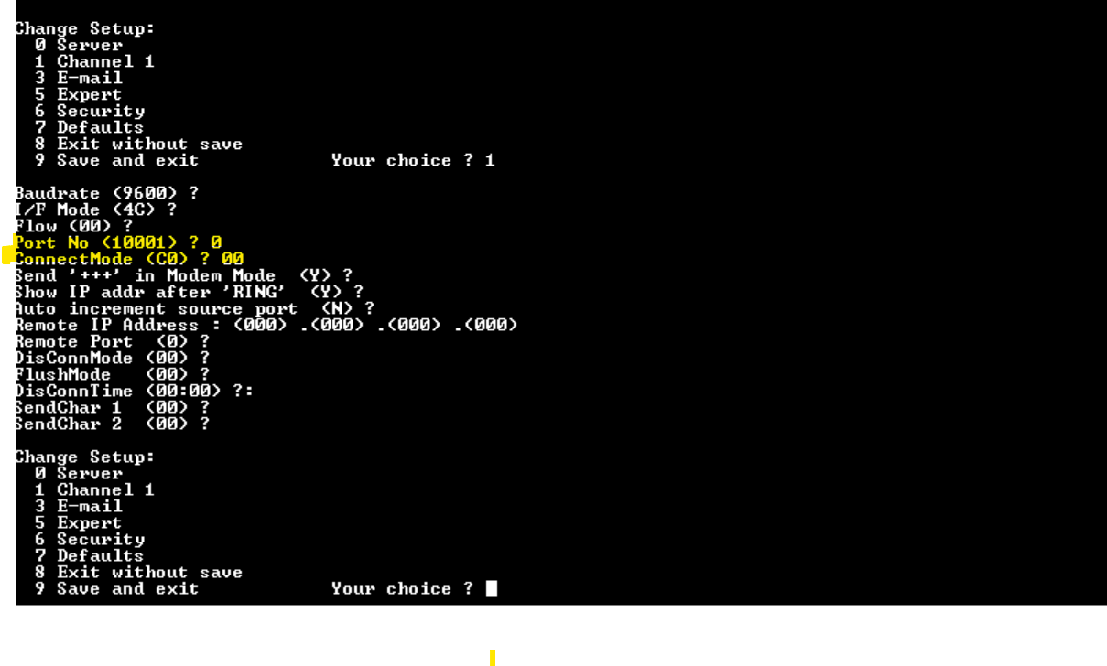

1. Set the default password and enable Telnet Authentication

* Goto security (option 6) and set below options.

. Enhanced password should be Y

. Change password Y and set password as you need.

Eg: here password set to “newpassword”

. Telnet Authentication to Y

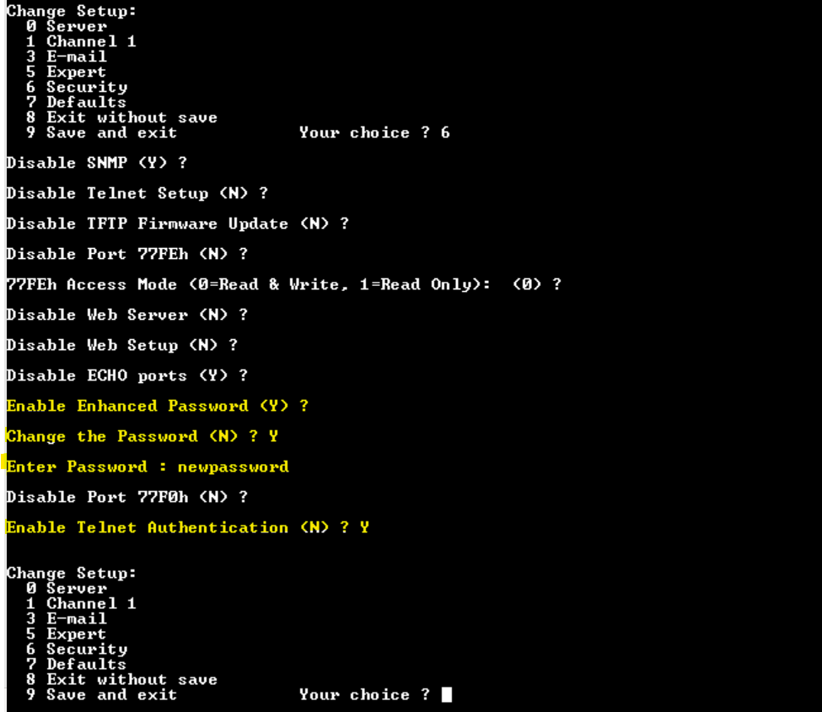

* Save and reboot.

. Select option 9 to save and reboot the device.